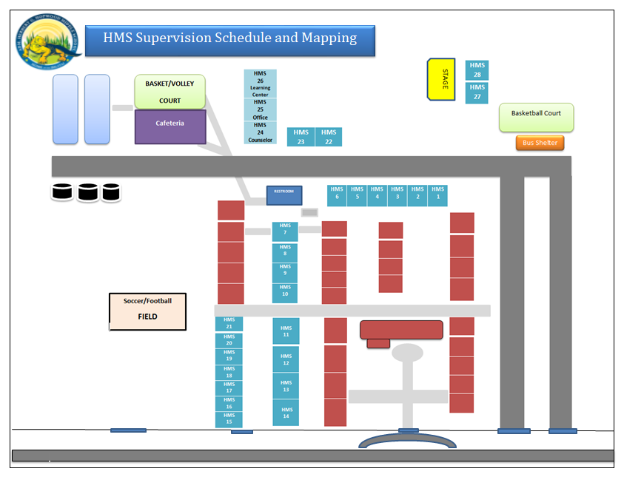

**HMS SCHOOL CAMPUS SY 2020-2021**

**HMS 1 – LC/PE**

**HMS 2 – CCLHS**

**HMS 3 – SCIENCE**

**HMS 4 – SOCIAL ST.**

**HMS 5 – MATH**

**HMS 6 – ELA**

**HMS 7 – LC/PE**

**HMS 8 – CTE**

**HMS 9 – ELA**

**HMS 10 – MATH**

**HMS 11 – SOCIAL ST.**

**HMS 12 – SCIENCE**

**HMS 13 – CCLHS**

**HMS 14 – CCLHS**

**HMS 15 – SCIENCE**

**HMS 16 – SOCIAL ST.**

**HMS 17 – MATH**

**HMS 18 – ELA**

**HMS 19 – CTE**

**HMS 20 – LC/PE**

**HMS 21 – MAINTANENCE**

**HMS 22 – CTE**

**HMS 23 – LIBRARY**

**HMS 24 – MAIN OFFICE**

**HMS 25 – COUNSELOR**

**HMS 26 – LEARNG CENTER**

**HMS 27 – CTE**

**HMS 28 - CTE**

|  |  |
| --- | --- |
| HMS  23 | HMS  22 |

|  |
| --- |
| HMS  26 |
| HMS  25 |
| HMS  24 |